**GENERAL HUMAN BIOLOGY – YEAR 12**

**TASK 4 – MUSCULAR SYSTEMS TEST**

***MULTIPLE CHOICE SECTION [5 MARKS]***

|  |  |  |  |  |
| --- | --- | --- | --- | --- |
| 1. | A |  | 3. | D |
| 2. | B |  | 4. | B |
|  |  |  | 5. | B |

***SHORT ANSWER SECTION [13 MARKS]***

1. The diagram below shows three types of muscle tissues labelled X, Y and Z

Identify each type of muscle tissue and list one place in the human body each type of tissue would be? [3 marks]

1. Muscle X: Skeletal muscle Examples include arms, legs, face, neck, trunk
2. Muscle Y: Cardiac muscle Example include heart
3. Muscle Z: Smooth muscle Examples include intestines, blood vessels, iris of

eye, stomach, gall bladder, bladder, uterus

1. The diagram shows Sally lifting weights from below her hips to a position directly above her head:
2. Name the term to best describe her arm movements as she raises her arms above her head ?

[1 mark]

* Abduction

1. Below is a diagram of someone raising their forearm towards their shoulder. Label the following terms on the diagram: [2 marks]  
   * *Agonist, antagonist, belly, origin, insertion*

Origin

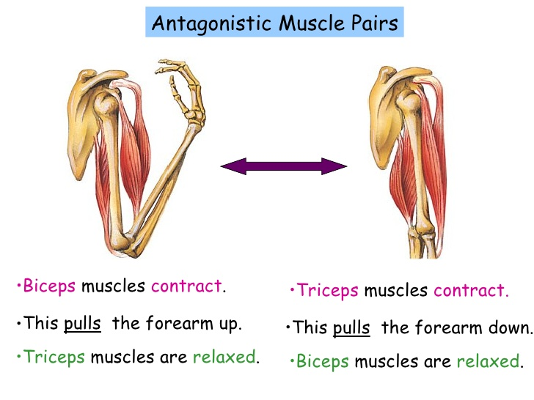

½ mark per response

Belly

Agonist

Insertion

Antagonist

1. Explain, using the movement shown in the diagram above, what is meant by the statement that “skeletal muscles are arranged in antagonistic pairs with the support of synergist”?

[3 marks]

*1 mark per correct point.*

*Any of the following but not limited to:*

* Each action of the body relies on pairs of muscles operating over a joint
* For example agonist contracts while the antagonist relaxes

1. Below is a diagram of muscle structure.  
     
   Label the following diagram on muscle structure. [4 marks]

*1 mark per correct name*

1. Muscle
2. Bundle of muscle fibres / muscle fibres / fascicle
3. Myofibril
4. Myofilaments / ac tin and myosin

***EXTENDED ANSWER SECTION [14 MARKS]***

1. Muscular strength and fibre type is related to the ability to balance the body in a set position. While maintaining a set position when balancing, the muscles have to be able to sustain a set level of contraction to keep the position. They do this by alternating the amount of contraction in each muscle fibre, relaxing some and contracting others. The ability to maintain a set varies between individuals.

* Both balancing times noted down (1)
* Average worked correctly (1)
* Working of average:
  + Add both balancing times (1)
  + Divide value by 2 (1)
* Comparison between person and athletes (1)
* Skeletal (1)
* Does not contract all at once because:
  + All fibres would fatigue /get tired at same time (1)
  + Alternating allows the load to be spread (1)
    - *Or something along these lines*
* Correct drawing of sarcomere
  + Actin (1)
  + Myosin (1)
  + Z-line (1)
* Explanation of contraction
  + Sarcomeres shorten (1)
  + Due to actin and myosin sliding over each other (1)
  + Z lines drawn closer together (1)